DEPARTMENT OFTHE ARMY
U.S. ARMY COMBINED ARMS CENTER AND FORT LEAVENWORTH
FORT LEAVENWORTH, KANSAS 66027-2326

REPLY TO
ATTENTION OF

IMLV-MWB 6 July 2020

MEMORANDUM FOR BOD, FMWR

SUBJECT: Trails West Golf Course Advisory Council (TWGCAC) Minutes,
24 June 2020

1. Administrative: Meeting opened at 1203.

a. Council Members Present:
COL James M. Depolo – TWGCAC Chairman
LTC Barry Mulligan – Active Duty Officer Representative
Mr. Mike Jones – Retiree Enlisted Representative
Mr. John Goodloe – Retiree Representative
Mrs. Susan Vold – Family Representative
Mr. Brian Prokes – TWGC Business Manager
Mr. Patrick Beach – TWGC Assistant Manager
Mr. Mike Boaz – TWGC Superintendent

b. Council Members Absent:
LTC Michael Bundt – Active Duty Officer Representative
SFC Gregory Fitzgerald – Active Duty Enlisted Representative
Mr. Gary Ely – General Patron Representative
Mr. Jerry Clark – DOD Representative
Ms. Ivana Nolke – Female Patrons Representative
Mr. Ken Riggins– DA Civilian Representative
Mr. Paul Martocci – FMWR Business Operations Officer

2. Old Business:

a. Item: Review of 3 Jun 20 minutes.

(1) FMWR accepted the Minutes as written. A copy of the Minutes may be found on the Trails West web site and the bulletin board inside the Golf Shop.

(2) The following local rule is established: Balls coming to rest in defined ornamental/decorative areas or wood chips surrounding the base of trees the player is entitled to a free drop one club length from the spot no closer to the hole.

(3) All local rules be officially recorded on the TWGC website and copy posted on the bulletin board in the hallway of the Pro Shop and local rules have to be approved and accepted by FMWR before TWGCAC can publish and post.

b Item: TWGCAC By-Laws.

(1) Discussion. LTC Mulligan researched and developed a set of by-laws for the TWGCAC and presented a proposed set of by-laws (Encl 1) to the TWGCAC. The TWGCAC members were provided the proposed by-laws prior to this meeting for review. LTC Mulligan and Mr. Prokes provided clarification on questions raised by those members present at the meeting. At the conclusion of the discussion the following motion was made by LTC Mulligan.

- TWGCAC accept the proposed by-laws as written and if changes are required in the future the change shall be presented at the monthly TWGCAC meeting; and the TWGCAC by-laws shall be published on the TWGC website.

The motion was seconded by Ms. Vold and passed with a unanimous vote.

(2) Recommendation. FMWR accept the TWGCAC By-laws as written and publish the TWGCAC By-Laws on the TWGC website and post a copy on the bulletin board in the Pro Shop.

c. Item: No mow area 18 Fairway.

(1) Discussion. Mr. Jones researched and presented several Courses of Action (COAs) (Encl 2) based on the discussions at the 3 Jun 20 meeting and the motion/proposal made by LTC Bundt to consider the no mow area on 18 as ground under repair. The TWGCAC members were provided some background information the proposed COAs prior to this meeting for review. The COAs presented were in accordance with the rules of golf. Mr. Prokes and Mr. Beach were able to provide clarification for questions concerning the COAs and an additional COA presented by Mr. Goodloe. At the conclusion of the discussion following motion was made by LTC Mulligan.

- TWGC patrons shall play the course as they find it, the ball as it lies, and red and yellow penalty areas are marked accordingly.

The motion was seconded by Mr. Jones and pass with a majority vote (3-2).

(2) Recommendation. FMWR add this statement to the TWGC website and post a copy on the bulletin board in the Pro Shop.

3. New Business:

a. Item: Maintenance Update
(1) Discussion:

(a) Mr. Boaz noted the maintenance staff recently applied a light top dressing on the greens and will continue to do so every 4 weeks.

(b) LTC Mulligan asked it be noted in the Minutes the great course conditions patrons are enjoying.

(2) Recommendation: None. For information only.

4. The Council was adjourned at

5. The TWGCAC next meeting will be 29 July 2020.

2 encl JAMES M. DEPOLO COL, SF
Chairman, TWGCAC

Reviewed by: BRIAN M. PROKES
Chief, Business Division
FMWR

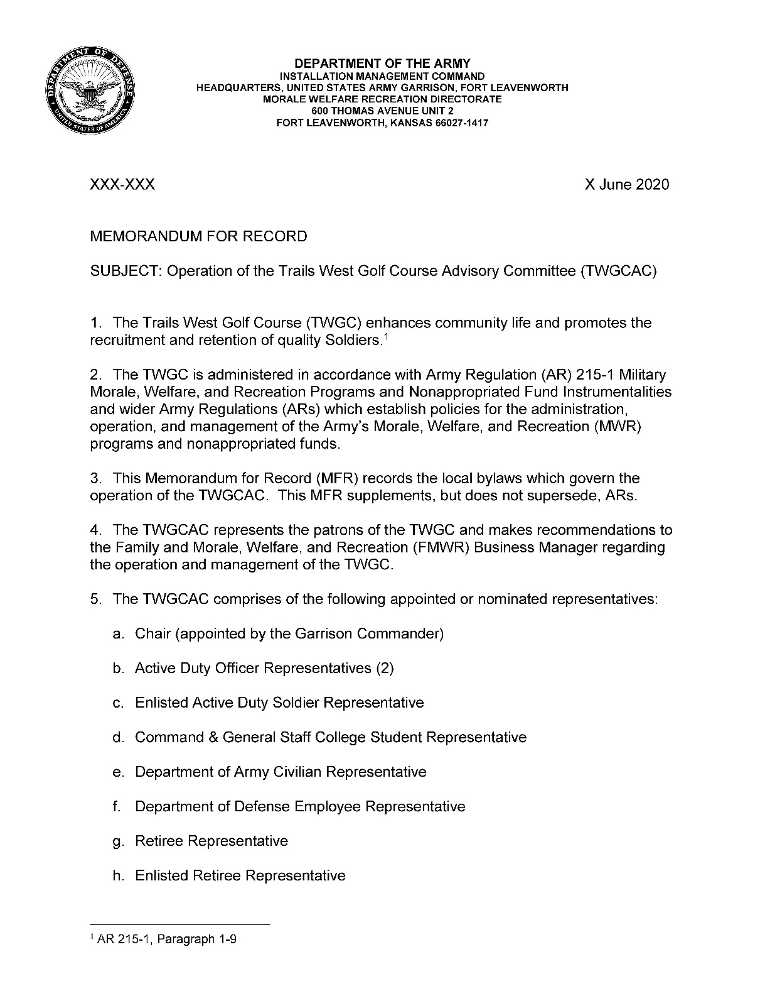
Enclosure 1

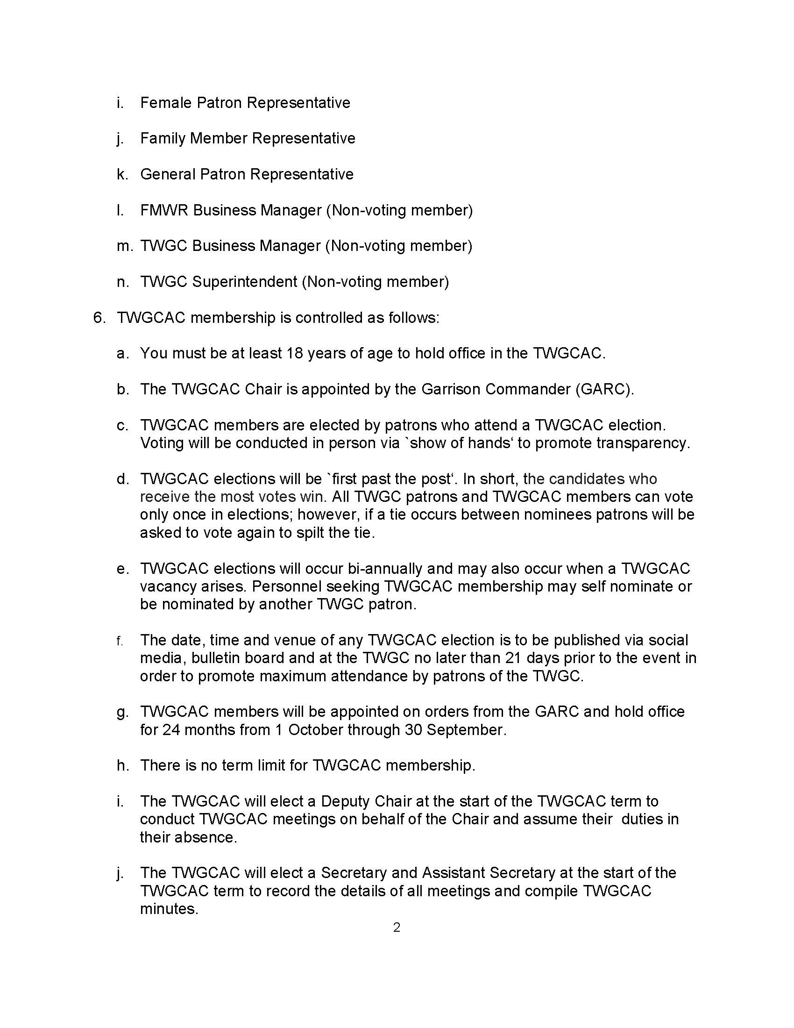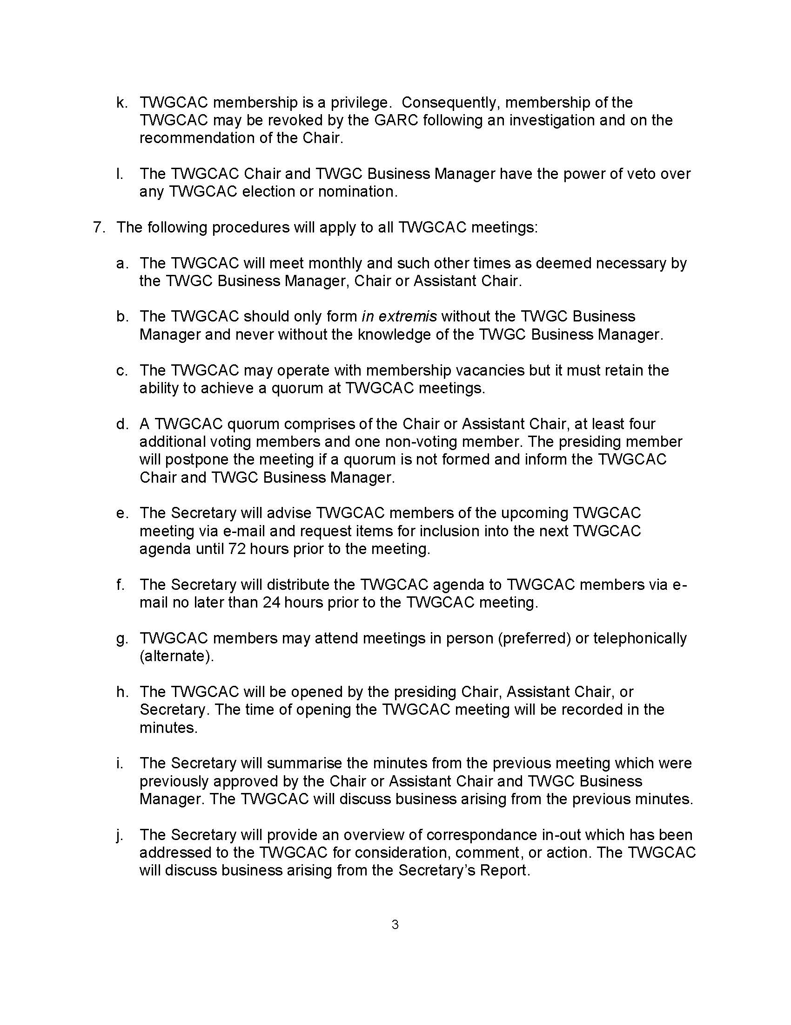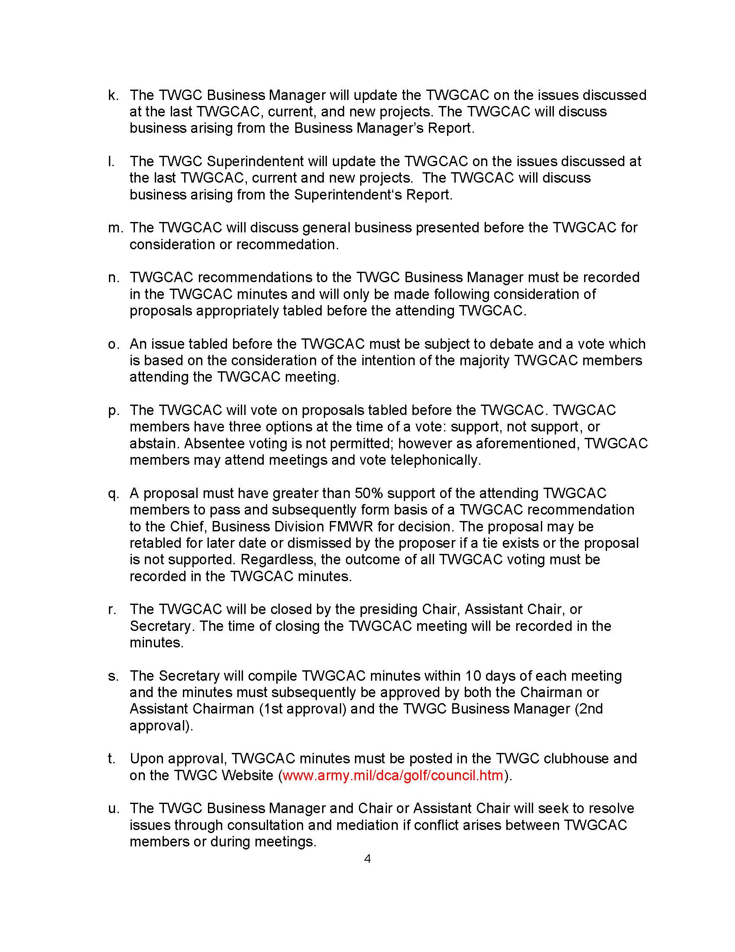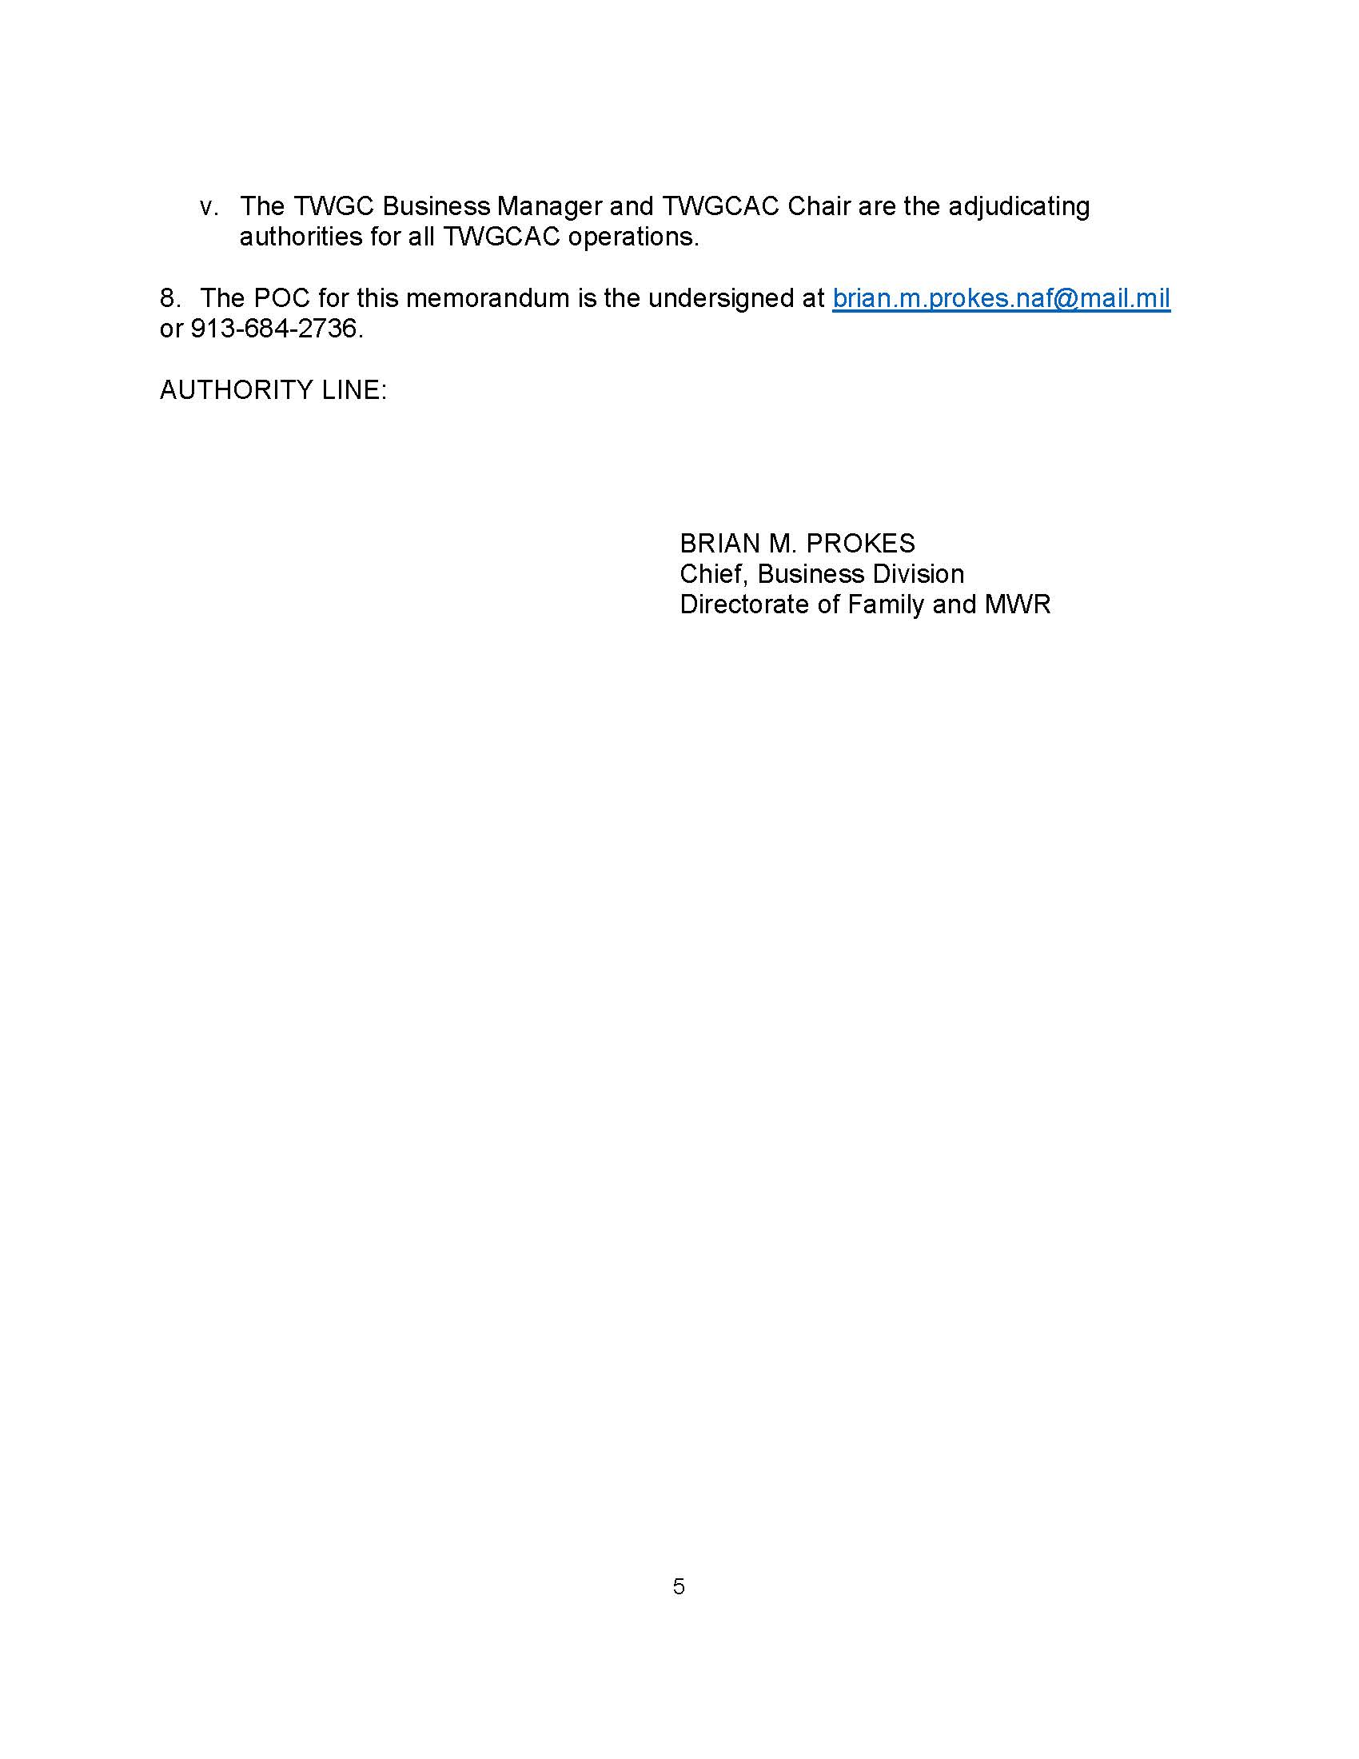

Enclosure 2
