Updated 04/13/2022

Spring/Summer ‘22

General Information

SKIESUnlimited is a part of the Army’s Division of Child and Youth Services under the Directorate of Family and Morale, Welfare and Recreation (Family and MWR). Our mission is to provide the children and youth of Fort Leavenworth with a variety of classes taught by qualified, imaginative, and dedicated instructors, creating experiences of value, excellence, and enjoyment. In addition, all Fort Leavenworth CYS SKIESUnlimited instructors have had local and national background checks, training in CPR, First Aid, Child Abuse Awareness, Reporting and Prevention, Guidance, Child Developmental Guidelines, and Safety.
Eligible Patrons: Eligible patrons for the SKIES program include children and youth whose sponsors are one of the following: active duty military, Fort Leavenworth DoD civilian employee (GS, NSPS, NAF, and DOD Contractor), Activated National Guard or Reservist, and retired military.
Registration Information: Registration for Child & Youth Services takes place at Parent Central, which is located in the Resiliency Center, 600 Thomas Avenue (Building 198). All students MUST be registered at Parent Central before enrolling in any SKIES programs. Registration is valid for 12 months and may be used for all Fort Leavenworth Child & Youth Service programming. The following information is required for registration: names and phone numbers of sponsor and spouse, two local emergency contacts, immunization records, current military email address, and a physical/health assessment. Patrons are given up to 30 days to submit local emergency points of contact and physicals.
Enrolling for SKIES Classes: Once you have completed the registration process, you may enroll/sign up for classes or programs at any Child & Youth Services location. You may also enroll by phone (684-3207) or by using the WebTrac online system https://webtrac.mwr.army.mil/webtrac/leavenworthcyms.html (user ID and password are available from Parent Central). Please be aware that enrollment is on a first-come, first-served basis. To ensure that your child retains his/her slot in a class, it is highly recommended that you enroll early in continuing sessions.
Payment Policy: Payment for SKIES classes is due at enrollment. Your child’s name will be placed on the roster only when payment has been made. We accept payment by cash, check, or credit/debit card. Second child discounts do not apply to any SKIES programs per Department of Army CYS Fee Policy.
Makeup Classes, Cancellation and Refund Policy: Refunds are NOT authorized for child illnesses, cancellations due to weather, family trips, or withdrawal after the class has started. Make up classes will be offered if at all possible, depending on the instructor's schedule. Refunds may be granted for extenuating circumstances such as prolonged absence due to illness or PCS orders. If you feel this is the case, a refund may be requested in writing to the SKIES Program Director. In the event a class is cancelled due to instructor unavailability, a makeup class will be offered, but no refund will be given. Class schedules are subject to change based upon instructor availability.
IMPORTANT NOTICE: RESCUE MEDS (e.g. inhalers, Epi-Pens) will NOT be administered by SKIES instructors. If a child requires an inhaler or Epi-Pen and is not authorized by a physician to self-administer, the parent is required to remain on site during the SKIES class.

Visit the following for up-to-date information on new SKIES classes:

- WebTrac https://webtrac.mwr.army.mil/webtrac/leavenworthcyms.html
- Family and MWR website https://leavenworth.armymwr.com
- CYS Facebook Page: www.facebook.com/cys.ftleavenworth
- Call the SKIES office at 913-684-3207

Parent & Student Safety
Instructors will be using the intermission times between class sessions to disinfect the equipment and areas used by the students. We will need your assistance in keeping classes and waiting areas safe.

- Current guidance for CYS requires everyone entering a CYS facility to wear a mask, except children under the age of two.
- If you or your student is not feeling well, please stay home for everyone’s safety. All efforts will be made to get the class made up.
- Please assist your child in washing their hands and then wash your hands upon entering the facility.
- A parent is required to wait in designated seating inside or outside the facility for the safety of your child.
- Students will be highly encouraged to maintain social distance during class.
- Participants are encouraged to come dressed for class.
- Instructors will sign students in and out.

Let’s work together.

Table of Contents

All schedules are subject to change due to instructor scheduling and availability.
Updates are posted on the CYS Facebook Page; like/follow to get notifications.

Some classes have a minimum enrollment required to begin. If a class is cancelled due to not meeting minimum enrollment, your fees will be refunded.

ARTS, RECREATION & LEISURE
Dance Classes General Information & Dance Class Descriptions
4 | Creative Movement/Pre-Ballet Description
4 | Ballet Description
Dance Class Sessions/Schedules:
5 | May
 | FITNESS & HEALTH
6 | Jr. Golf Lessons
7 | Gymnastics
8 | Gymnastics Schedules
9 | Gymnastics Schedules
10 | Yoga Camp
11 | Swimming Description
12 | Swimming Schedule May/June
MORE ARTS, RECREATION & LEISURE with PRIVATE MUSIC LESSONS
13 | Piano
13 | Guitar / Ukulele
14 | Recruiting Information SKIES Contractors/Instructors (ongoing)

Arts, Recreation, & Leisure Classes

Dance Classes
Ages: 3+
Cost: $12 per lesson
Total fee based on number of classes offered per session. Classes will not meet during Federal Holidays, or USD 207 winter, or Spring Break. Fees are not charged for the breaks or holidays.
Instructor: Holly Harmison
Location: SKIES Building (Patch Community Center), 320 Pope Avenue (Bldg. 345)
Parents must wait in designated waiting areas & follow all health & safety requirements.

Important notes for dancers:
- Dress code is black or pink leotard, pink tights and ballet, jazz or tap shoes
- Boys are asked to wear black dance pants and white t-shirt with black dance shoes.
- Hair must be in a ponytail, pinned bun, or pinned back for every class by student or parent.
- Parents are encouraged to let their child try the class prior to investing to meet the dress code.
- Street shoes and bare feet are not allowed in the Dance Studio.
- Please bring your students dressed for class; they can put their dance shoes on once inside the SKIES building.

CLASS DESCRIPTIONS FOR DANCE
Creative Movement/Pre-Ballet for 3-4 years
Dancers will explore movement and rhythm as it relates to their bodies and space.
Basic coordination and locomotor skills will be developed with the aid of imagery, props, and music. Ballet skills will be introduced and the development of posture, flexibility, rhythm, and poise are the goals of the class.
Ballet for 5-9 year olds
Basic ballet skills will be learned in a relaxed but structured environment. Dancers will learn proper ballet terminology and pair it with the correct movements. Barre exercises will be introduced as well as work in the center.
Jazz & Tap
Dancers will spend 25 minutes exploring each dance style. Traditional jazz technique will be introduced and skills such as body isolation, turning, jumping, and leaping. Dancers will learn basic tap steps and will combine traveling steps in the dance space.

Session Schedules

April Dance lessons may still be available. Fees will be pro-rated.
May
Class Schedule | Ages | Day | Times | Dates | Fee | # of classes
Ballet | 5-6 yrs. | Tuesdays | 1615-1700 | May 3-24 | $48 | 4
Ballet | 7-10 yrs. | Tuesdays | 1700-1745 | May 3-24 | $48 | 4
Creative Movement/Pre Ballet | 3-4 yrs. | Tuesdays | 1800-1845 | May 3-24 | $48 | 4
Jazz & Tap co-ed | 7-10 yrs. | Wednesdays | 1600-1645 | May 4-25 | $48 | 4
Creative Movement/Pre Ballet | 3-4 yrs. | Wednesdays | 1700-1745 | May 4-25 | $48 | 4
Ballet | 5-6 yrs. | Thursdays | 1700-1745 | May 5-26 | $48 | 4

Pre-Ballet, Ballet and Jazz & Tap classes will return in the Fall.
Fall classes will be available for Tuesday or Wednesday enrollment.

Fitness and Health
Jr Golf
Ages: 7+
Cost: $75 Instructor: Nancy Hoins
Location: Trails West Golf Course
Parents must wait in a designated waiting areas
& follow all health & safety requirements.
Session #1 April 19-21 4:15-5:45 pm
Sessions 2-6 Open April 18th at 9:00 am
Session #2 May 24-26 4:15-5:45 pm
Session #3 Jun 14-16 9:00-10:30 am
Session #4 Jun 28-30 9:00-10:30 am
Session #5 Jul 12-14 9:00-10:30 am
Session #6 Jul 26-28 9:00-10:30 am

Additional sessions will open with the Fall SKIES classes
The Jr Golf Clinic will focus on the fundamentals of golf. Participants will learn to hold the golf club properly (grip), stance, posture, alignment (aiming). The lessons in the clinic will cover the short game as well as the long game. This is to include chipping, pitching, putting, iron play, driving, sand play, and how to play in a scramble. Learn how to play golf with etiquette, safety and an understanding of the rules. Emphasis is on having fun and learning to play a life time game.
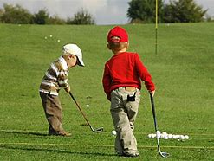

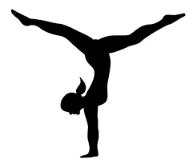

Gymnastics Class Descriptions

Parent/Tot Gymnastics, 1 years old and 2-3 years old
Parent and child will work together to learn essential gymnastics skills, make new friends
and enjoy conquering the new challenges presented to them in the new circuits each week!

Parent/Tod Gymnastics Family 2-6
Parent and children will work together to learn essential gymnastics skills. This class is designed for families with siblings they prefer in the same class.

Pre-Gym, 4-5 years
Children receive the opportunity to participate in gymnastics class independently and learn
basic gymnastics skills at a faster pace!

Beginning Gym, 6+ years
An entry level class designed for kids who don’t have any prior gymnastics experience
OR who still need to polish up their basic skills! They will be taken to a new apparatus each
week in order to accelerate the pace at which they pick up essential gymnastics skills.

Tumbling, 6+ years
This class is suited to anyone that has an interest in learning how to tumble! Every class
focuses on proper technique and constantly adding to their repertoire of skills! This class is
also appropriate for budding cheerleaders who would like to add tumbling to their list of skills.

If you need some assistance with enrolling or have questions, please call 913-684-3207.
Participants in gymnastics must be enrolled.

Gymnastic Class Fee Schedule
30 minute classes billed at $11 per session x number of sessions
45 minute classes billed at $13 per session x number of sessions

Gymnastics June Classes

Jun 1 – Jun 30 | Day | Time | Dates | Fee | # of  sessions
Parent/Tod 1 yr | T | 0930-1000 | Jun 7 – Jun 28 | $44 | 4
Parent/Tot 2-3 years | T | 1015-1055 | Jun 7 – Jun 28 | $52 | 4
Pre Gym 4-5 years | T | 1115-1155 | Jun 7 – Jun 28 | $52 | 4
Pre-Gym 4-5 years | T | 1615-1655 | Jun 7 – Jun 28 | $52 | 4
Beg Gym 6+ years | T | 1715-1755 | Jun 7 – Jun 28 | $52 | 4
Tumbling 6+ years | T | 1815-1855 | Jun 7 – Jun 28 | $52 | 4
Parent/Tod 2-6 years | W | 1130-1210 | Jun 1 – Jun 29 | $65 | 5
Pre-Gym 4-5 years | W | 1530-1610 | Jun 1 – Jun 29 | $65 | 5
Parent/Tod 1yr | W | 1630-1700 | Jun 1 – Jun 29 | $55 | 5
Parent/Tod 2-6 years | W | 1715-1755 | Jun 1 – Jun 29 | $65 | 5
Pre Gym 4-5 years | Th | 0930-1010 | Jun 2 - Jun 30 | $65 | 5
Beg Gym 6+ years | Th | 1030-1110 | Jun 2 - Jun 30 | $65 | 5
Tumbling 6+ years | Th | 1130-1210 | Jun 2 - Jun 30 | $65 | 5
Parent/Tot 2-3 years | Th | 1530-1610 | Jun 2 - Jun 30 | $65 | 5
Beg Gym 6+ years | Th | 1630-1710 | Jun 2 - Jun 30 | $65 | 5
Pre-Gym 4-5 years | Th | 1730-1810 | Jun 2 - Jun 30 | $65 | 5

*Class fees are determined by length of class and number of sessions per month.

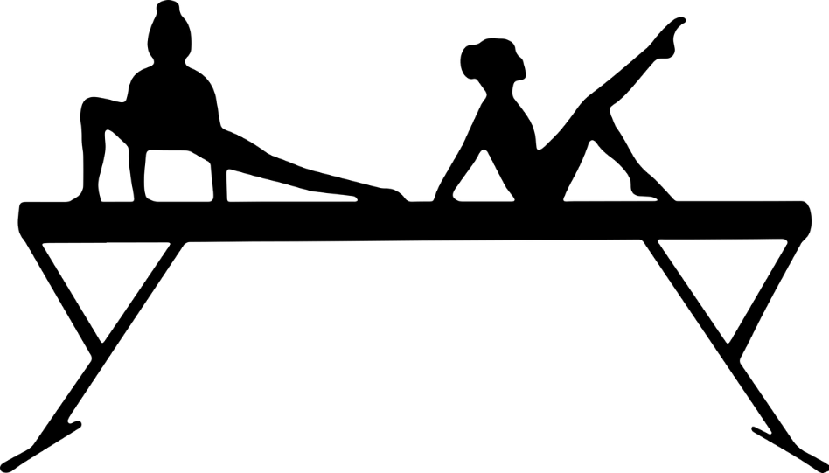

Gymnastics July 5-28 Classes

Jul 12 – Jul 28 | Day | Time | Dates | Fee | # of  sessions
Parent/Tod 1 yr | T | 0930-1000 | Jul 5 – Jul 26 | $44 | 4
Parent/Tot 2-3 years | T | 1015-1055 | Jul 5 – Jul 26 | $52 | 4
Pre Gym 4-5 years | T | 1115-1155 | Jul 5 – Jul 26 | $52 | 4
Pre-Gym 4-5 years | T | 1615-1655 | Jul 5 – Jul 26 | $52 | 4
Beg Gym 6+ years | T | 1715-1755 | Jul 5 – Jul 26 | $52 | 4
Tumbling 6+years | T | 1815-1855 | Jul 5 – Jul 26 | $52 | 4
Parent/Tod 2-6 years | W | 1130-1210 | Jul 6 – Jul 27 | $52 | 4
Pre-Gym 4-5 years | W | 1530-1610 | Jul 6 – Jul 27 | $52 | 4
Parent/Tod 1yr | W | 1630-1700 | Jul 6 – Jul 27 | $44 | 4
Parent/Tod 2-6 years | W | 1715-1755 | Jul 6 – Jul 27 | $52 | 4
Pre Gym 4-5 years | Th | 0930-1010 | Jul 7 – Jul 28 | $52 | 4
Beg Gym 6+ years | Th | 1030-1110 | Jul 7 – Jul 28 | $52 | 4
Tumbling 6+ years | Th | 1130-1210 | Jul 7 – Jul 28 | $52 | 4
Parent/Tot 2-3 years | Th | 1530-1610 | Jul 7 – Jul 28 | $52 | 4
Beg Gym 6+ years | Th | 1630-1710 | Jul 7 – Jul 28 | $52 | 4
Pre-Gym 4-5 years | Th | 1730-1810 | Jul 7 – Jul 28 | $52 | 4
Parent/Tod 1yr | Sa | 0900-0930 | Jul 16-Jul 30 | $33 | 3
Parent/Tot 2-3 years | Sa | 0945-1025 | Jul 16-Jul 30 | $39 | 3
Parent/Tod 2-6 years | Sa | 1045-1125 | Jul 16-Jul 30 | $39 | 3
Pre-Gym 4-5 years | Sa | 1145-1225 | Jul 16-Jul 30 | $39 | 3
Beg Gym 6+ years | Sa | 1315-1355 | Jul 16-Jul 30 | $39 | 3

*Class fees are determined by length of class and number of sessions per month

Yoga Camp

Date: June 13th-17th Time: 1300-1500
Ages: 7-11 years of age
Cost: $100 Instructor: Rachel Dugan
Location: SKIES Building (Patch Community Center), 320 Pope Avenue (Bldg. 345)
Parents must wait in designated waiting areas & follow all health & safety requirements.
Minimum enrollment is four enrolled students.

Kids’ Yoga camp meets for one week, Monday through Friday for two hours. The students will move through a physical yoga practice every day as well as breath work and meditation techniques. Art, writing, and skit projects will reinforce the yoga themes they will be exposed to. Yoga camp is a creative and physical way for kids to have fun and de stress. Children will need a towel, and a source of water. If you have a yoga mat, please bring it. There will be some mats available for participant use.

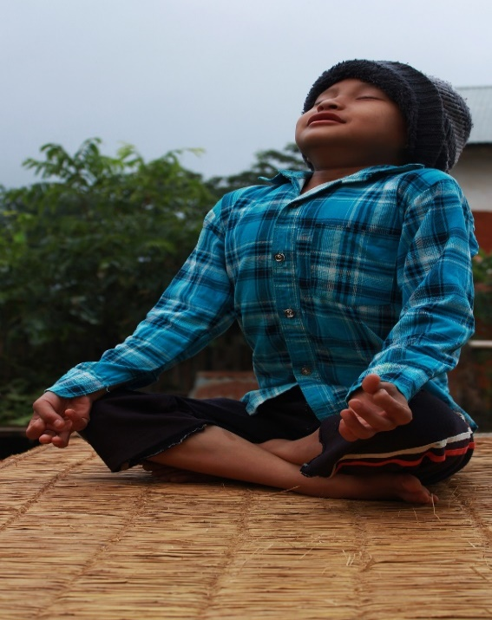

Please follow the Fort Leavenworth Child &Youth Services page on Facebook for current information on schedule and enrolling.
Spaces are limited.

Swimming Level Descriptions:
PRESCHOOL: (*3 and 4 year olds) – Introduction to swimming. Includes instruction on: Entering and exiting the pool safely, Blowing bubbles, Gliding, Floating, Front crawl and Elementary backstroke. Instructor will provide support and assistance with skills if needed. Participants must be potty-trained or wear an approved swim diaper.
No prerequisites are required.

LEVEL 1: (* 5 year old and up) – Includes instruction on: Pool Safety,
Recognizing an emergency, Floating, Front Crawl, Elementary backstroke. Instructor will provide support and assistance with skills if needed.
No prerequisites are required.

LEVEL 2: (* 5 years old and up) – Includes instruction on: Pool Safety,
Floating, Front Crawl, Elementary backstroke, Treading, Submerging and Object retrieval. Instructor will assist with body corrections for participant if needed. Prerequisites for this level are the ability to submerge fully and resurface, float independently, and to be able to move independently for 5 – 10 feet in the water independently.

LEVEL 3: (* 5 years old and up) – Includes instruction on: Pool Safety, Stroke Fundamentals, Floating/Treading, Front Crawl, Elementary backstroke, Breaststroke, Backstroke, Object retrieval. Instructor will assist with body corrections for participant if needed. Prerequisite for this level are the ability tread to change direction while swimming to locate an exit, must be able to perform Front Crawl and Elementary backstroke for a minimum of 20 feet independently.

LEVEL 4: (* 5 years old and up) – Includes instruction on: Pool Safety, Treading, Front Crawl, Breaststroke, Backstroke, Butterfly, Diving entries. Stroke Correction. Participant should be able to take verbal corrections, but minor body corrections may be made by the instructor. Prerequisites for this level are the ability to tread and change direction while swimming to locate an exit, must be able to perform Front Crawl, Backstroke, and Breaststroke, for a minimum of 25 yards independently.

Swimming May-June Classes

 | May 10th | May 12th | May 17th | May 19th | May 24th | May 26th | May 31st | June 2nd
Pre-School | 1500-1530 | 1500-1530 | 1500-1530 | 1500-1530 | 1500-1530 | 1500-1530 | 1500-1530 | 1500-1530
Level 1 | 1630-1700 | 1630-1700 | 1630-1700 | 1630-1700 | 1630-1700 | 1630-1700 | 1630-1700 | 1630-1700
Level 2 | 1545-1615 | 1545-1615 | 1545-1615 | 1545-1615 | 1545-1615 | 1545-1615 | 1545-1615 | 1545-1615
Parent & Child | 1715-1745 | 1715-1745 | 1715-1745 | 1715-1745 | 1715-1745 | 1715-1745 | 1715-1745 | 1715-1745

Additional Dates not available upon publishing. Please contact the SKIES director for more information on possible additional Swimming class dates.

Learning to swim is an important life skill, unless you were born a fish.

Private Music Lessons
Ages: 7 to 18 years
Time: Varies. Coordinate with instructor for schedule.
Cost: $19 per lesson weekly, enrolling now 30 minutes per lesson
Location: Patch Community Center/SKIES, 320 Pope Avenue Bldg. 345
Read about our instructors and call them for openings and to schedule lessons.
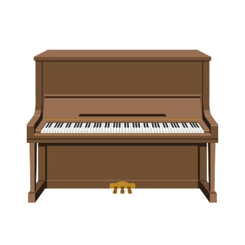
Please contact the SKIES office at 684-3207 for more information.

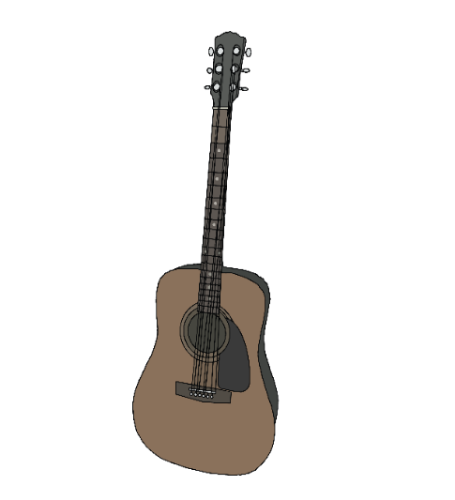
Piano
Instructor: John Leon
Call Mr. Leon directly to set up lesson schedule. 913-702-2484
The instructor will contact the SKIES Director to process enrollment when a schedule has been set. You will be contacted by the SKIES program to make payment at this time.

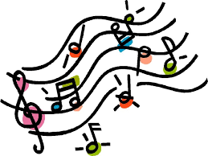

Guitar or Ukulele
Instructor: Ronald Meier
Sessions: Lessons are offered on Tuesdays.
Call Mr. Meier directly to set up lesson schedule. 785-424-4782
The instructor will contact the SKIES Director to process enrollment when a schedule has been set. You will be contacted by the SKIES program to make payment at this time.

SKIES Recruitment

The SKIES program needs instructors with the skills to teach the following. Do you have the skills or know someone that does?

- Drawing/Cartooning
- Painting
- Tae Kwon Do
- Hapkido or Aikido
- Okinawan Karate
- Judo
- Life Skills for Pre-Teen and Teens
- Basic Carpentry
- Cooking (Basic, Intermediate and or International, etc.)
- Money Management & Skill
- Music Exploration for Toddlers
- Zumba
- Computer Coding

- Employee to teach Tumbling
- Violin/Cello/Bass/Viola
- Science/STEM/STEAM
- Hip Hop Dance
- Manners & Hygiene
- Hiking
- Fitness/Conditioning
- Yoga
- Art Appreciation/Photography
- Public Speaking
- Sign Language
- Tutoring

Additional class ideas are welcomed!

For more information, please contact SKIES Director:
913-684-3207

Cell Phone: 913-704-7595

